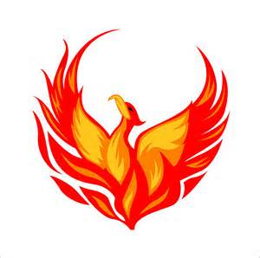

2017-2018 Class Schedule

Activity & Early Release Schedule

9:00 – 10:00 1st Period
10:00 – 10:25 Meeting
(10:00 – 10:10 – Snack/Social Time)
10:25 – 11:25 2nd Period
11:25 – 12:10 Lunch
12:10 – 1:10 3rd Period
1:10 – 2:00 4th Period
2:00 – 3:30 Activity Period

