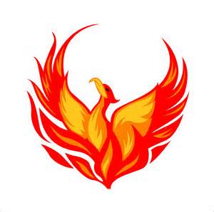

2017-2018 Class Schedule

9:00 – 10:30 1st Period
10:30 – 10:55 Meeting
(10:30 – 10:40 – Snack/Social Time)
10:55 – 12:25 2nd Period
12:25 – 1:10 Lunch
1:10 – 2:40 3rd Period
2:40 – 3:30 4th Period

